Software Engineering Personal Report

The past two weeks were the first two weeks for our group to start the project. In the winter vacation, we had decided our Belbin model and I chose the role of shaper in the Belbin team.

In the first online meeting, we had planned for the first two weeks’ main work. It mainly had three points:

1. Analyze business requirement and write user story.

2. UI design for both web and android application.

3. Simple implementation in android application: login and register system.

I was mainly contributed to the third task: implementing the login and register system in android application. Firstly, I read a lot of books about android application’s development, and decided to use Android Studio to develop this application.

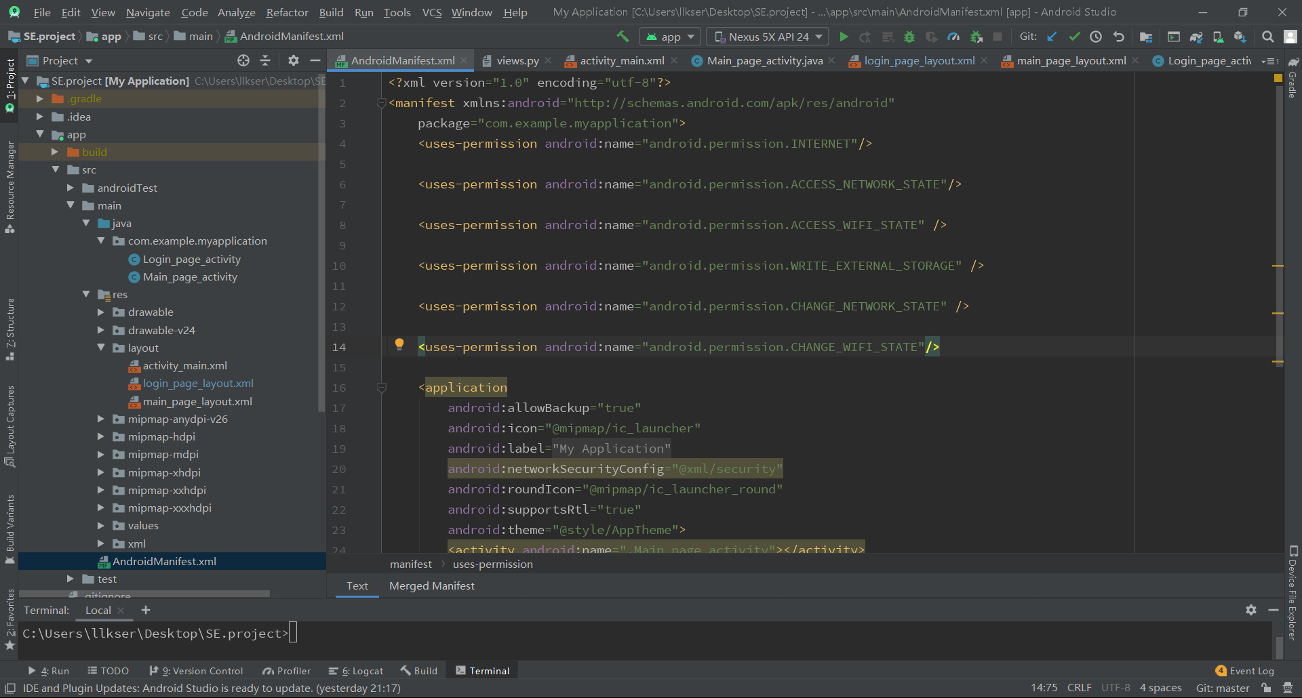

Because the UI design hadn’t been completed, we had used the layout designer in Android Studio to develop a simple page to implement and test the login and register system.

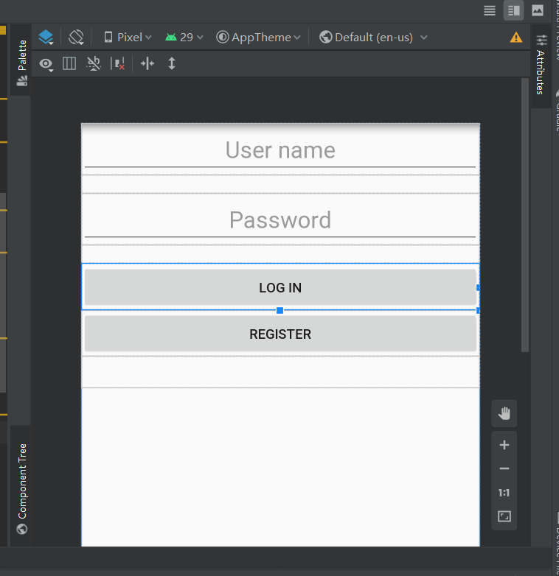

In the final test, the login system worked well in the mobile simulator. And the application had been packaged to install in android mobile phones. The application had been tested in various mobile phones including MI6, Huawei and so on.

